**Question: Create a React Application named “ticketbookingapp” where the guest user can browse the page where the flight details are displayed whereas the logged in user only can book tickets.**

**The Login and Logout buttons should accordingly display different pages. Once the user is logged in the User page should be displayed. When the user clicks on Logout, the Guest page should be displayed.**

**App.js:**

import React, { useState } from 'react';

import GuestPage from './GuestPage';

import UserPage from './UserPage';

import './App.css';

function App() {

const [isLoggedIn, setIsLoggedIn] = useState(false);

const toggleLogin = () => {

setIsLoggedIn(prev => !prev);

};

let page;

if (isLoggedIn) {

page = <UserPage />;

} else {

page = <GuestPage />;

}

return (

<div className="App">

<h1>✈️ Ticket Booking App</h1>

<button onClick={toggleLogin}>

{isLoggedIn ? 'Logout' : 'Login'}

</button>

<hr />

{page}

</div>

);

}

export default App;

**Guestpage.js:**

import React from 'react';

const GuestPage = () => {

return (

<div>

<h2>Guest Page</h2>

<p>You are browsing as a guest. Please login to book your tickets.</p>

<h3>Available Flights:</h3>

<ul>

<li>Chennai ✈️ Delhi</li>

<li>Mumbai ✈️ Bangalore</li>

<li>Hyderabad ✈️ Kolkata</li>

</ul>

</div>

);

};

export default GuestPage;

**Userpage.js**

import React from 'react';

const UserPage = () => {

return (

<div>

<h2>User Page</h2>

<p>Welcome! You can now book your flight tickets.</p>

<h3>Book Your Flight:</h3>

<ul>

<li>Chennai ✈️ Delhi - <button>Book</button></li>

<li>Mumbai ✈️ Bangalore - <button>Book</button></li>

<li>Hyderabad ✈️ Kolkata - <button>Book</button></li>

</ul>

</div>

);

};

export default UserPage;  
  
**output:**

**Guestpage:**

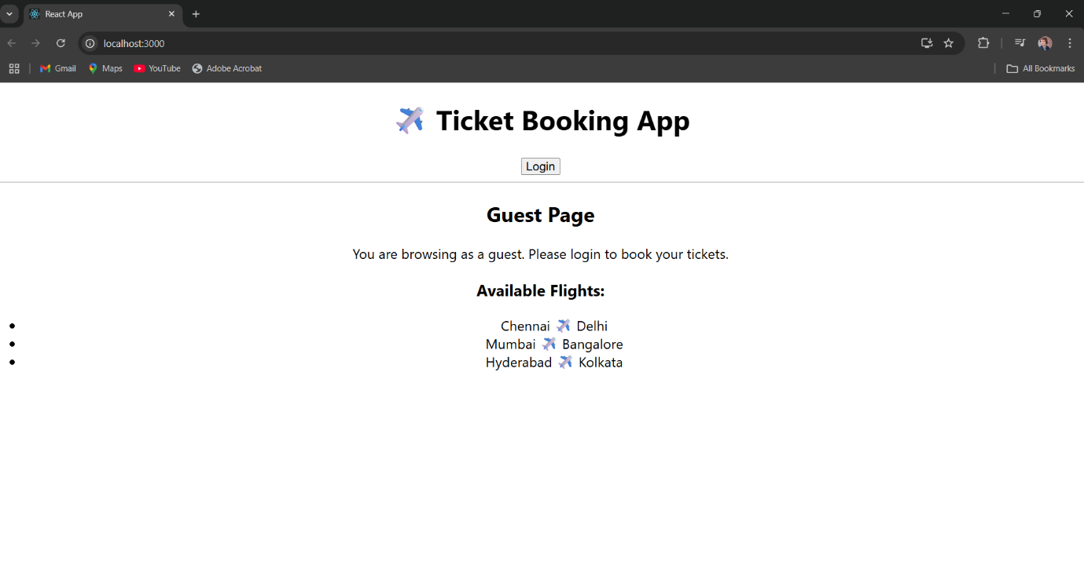

**UserPage:**

